FM Receiver with Si4703 DSP & RDS Decoding
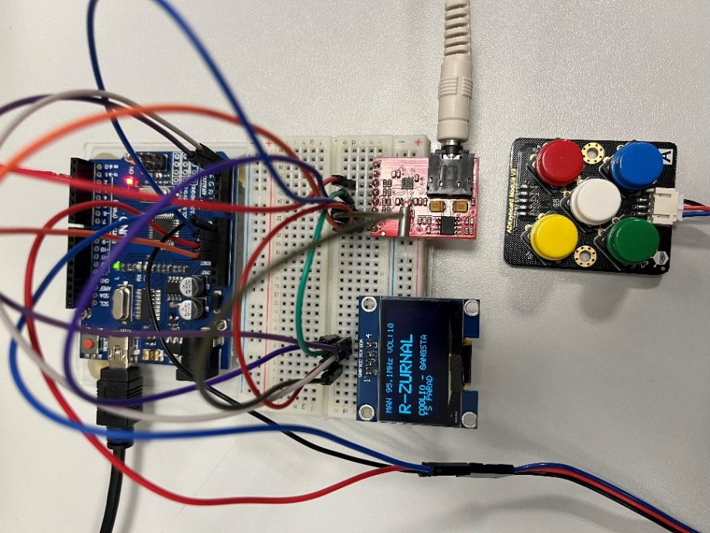
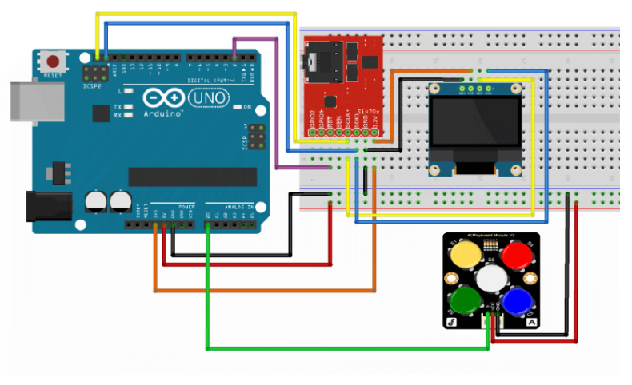


Team members
- Mezera Vojtěch
- Moravec David
- Mostecký Filip
- Pavlíček Michal

Git hub

Analog Keypad Control
- S1 – next station / increase frequency
- S2 – previous station / decrease frequency
- S3 – volume down
- S4 – volume up
- S5 – toggle tuning mode (AUT ↔ MAN)

Radio Functions

Automatic Mode (AUT)
- Default at start
- Scans FM band, evaluates signal via si4703_getRSSI()
- Threshold: 20 (0–127); stations ≥19 saved to list
- S1/S2 cycle through list (wrap-around enabled)

Manual Mode (MAN)
- Activated by S5
- S1: +0.1 MHz, S2: –0.1 MHz

Volume
- S3: down, S4: up
- Value shown on OLED display

RDS
- Displays station text if available
- Updates dynamically
- Shows last valid text or if unavailable -----
Firmware Architecture
Event-Driven Design & Multitasking The firmware operates on a non-blocking main loop principle to ensure system responsiveness.
Auto-Scan Algorithm
Explains the logic in automaticke_ladeni function in main.c.
Signal Quality Evaluation Upon startup, the system performs an automatic bandwidth scan (87.5 MHz – 108.0 MHz):
- The tuner seeks the next available carrier frequency.
- The microcontroller reads the RSSI (Received Signal Strength Indicator) from the Si4703 registers.
- Only stations exceeding the defined signal threshold (RSSI > 20) are stored in the RAM station list.
;

Abstract
This project implements a robust FM radio receiver utilizing the Si4703 DSP tuner and ATmega328P microcontroller. Key features include automatic station seeking with signal quality evaluation (RSSI), a memory system for 20 stations, and non-blocking RDS decoding for real-time text display without user interface latency. Inputs are handled via an ADC resistor-ladder keyboard to conserve GPIO pins.

